National Junior College Athletic Association
2013 Division II Volleyball National Championships
Pre-Tournament Information
November 21-23, 2013

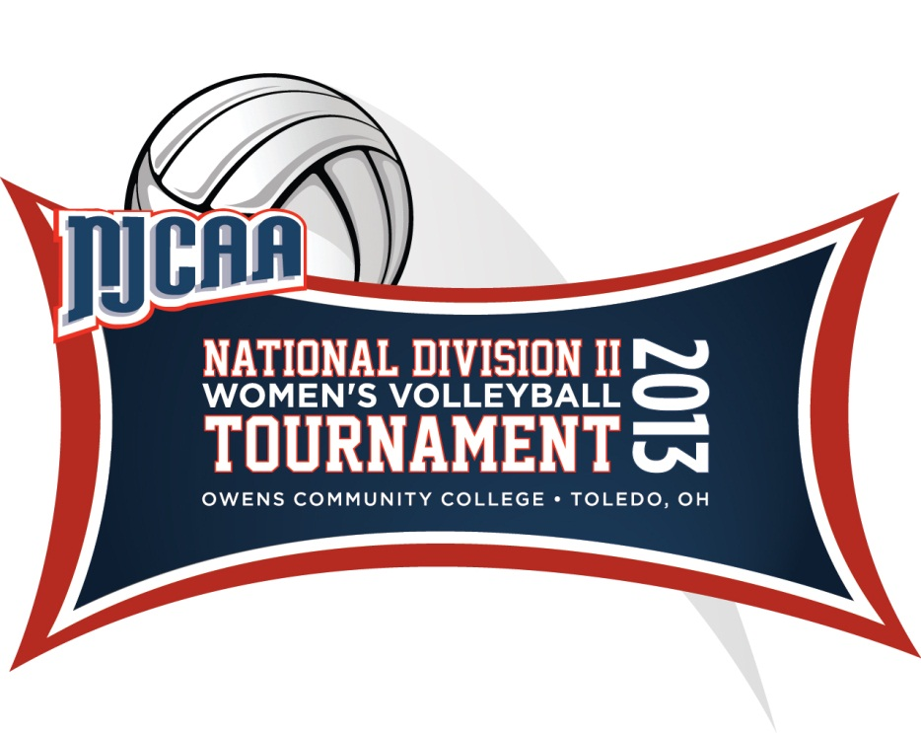

Owens Community College
Student Heath and Activities Center
30335 Oregon Road
Perrysburg, OH 43551
1-800-GO-OWENS, Ext. 7973
567-661-7973
www.njcaa.org

2013 NJCAA Division II Volleyball Championships

Championship Host
Owens Community College
30335 Oregon Road
Perrysburg, OH 43551
(567) 661-7973

Championship Site
Owens Community College
30335 Oregon Road
Perrysburg, OH 43551

Championship Dates
November 21-23, 2013

Championship Committee

Tournament/Athletic Director……….……………………………………Rudy Yovich
Manager, Marketing………………………………………………………Andrew Woodard
Athletics Specialist………..………………………………………………Ann LaVoy
Website/Media Relations………………………………………………….Nicholas Huenefeld
NJCAA Representative……………………………………………………Carl Heinrich

Contact Information

Tournament Contact Information
Rudy Yovich………………………………………….……………rudy_yovich@owens.edu
Sonny Lewis…………………………………………..…………...slewis@owens.edu
Ann LaVoy………………………………………………….……..ann_lavoy@owens.edu

Hotel Contact Information
Holiday Inn French Quarter, Fran Brown – (419) 874-3111
10630 Fremont Pike, Route 20, Perrysburg, OH 43551
Please bring your tax exempt form upon check-in

Website Information

Owens Express Website for National Tournament Updates
www.owensexpress.com

General Tournament Information

Tournament Program
The team registration form team roster, logo, 5 x 7 team pictures, media outlet form, banquet reservation and merchandise order form should be e-mailed to rudy_yovich@owens.edu upon qualifying for the National Tournament by 12 noon EST, on Tuesday, November 12.
Items Must Include:
High Resolution Color Photo 300 .dpi . jpeg
High Resolution Color Logo 300 .dpi .jpeg
Team Registration Form, Dinner Reservation Form, T-shirt Order Form, and Media Contact Form
Please use the word document attached to provide your Team Roster information completing all areas of information.

DEADLINE for submitting all above information online is Tuesday, November 12, 2013 by 12 noon EST. *Do not submit any information until your team has qualified.

Tournament Credentials
Tournament credentials will be issued for each person on the official team roster. All others in attendance must purchase their own tickets. Each participating college will receive tournament passes for the Athletic Director and President; please list on the Official Entry Form if they will be in attendance. All players and coaches must present passes upon entry. Tournament passes will be handed out in your check-in packet.

Tickets
3 day tournament pass- $35
1 day entry ticket- $15
Children 12 and under - $5 per day

Team Check-In
Teams may check in between the hours of 8:30 a.m. until 4:30 p.m. at Owens Community College prior to your scheduled practice time on Wednesday, November 20th. Please bring with you a check payable to Owens Community College for your banquet tickets and merchandise purchased for your team. No credit cards please. Please also arrive one-half hour prior to your practice time for a team photo upon entry in to the gym. We have requested that hotel rooms be available beginning at 12:00 noon on Wednesday. Coaches and/or administrators should bring tax exempt information/forms with them to hotel check in. Please note that hotel rooms on hold are for participating teams, coaches and NJCAA Staff only. Additional local hotel information for family, friends and fans can be found further in this document.

Mandatory Coaches Meeting
There will be a Mandatory coaches meeting in the Forum Room at the Holiday Inn French Quarter on Wednesday, November 20, at 5:30 p.m. before the Team Banquet. All Coaches are required to attend.

Team Banquet
The banquet is open to team members, coaches, team personnel and college administrators only. We cannot accommodate parents or others not associated with the college and/or team. The team banquet will be held on Wednesday, November 20th, at 7:00 p.m. and will be held in the Depot Ball Room at the Holiday Inn French Quarter. Please note: Teams must arrive by 6:00 p.m. for team photos prior to the banquet. All banquet tickets for team members, team administrators, staff, and VIP must be reserved by the coach and sent in with all papers by Tuesday, November 12th. Dress for the banquet is business professional. Coaches should purchase tickets by e-mailing their reservation form to ann_lavoy@owens.edu and bringing the check to Owens Community College upon check-in. Dinner tickets are $25 per person.

Photos
A Professional Photographer will be at the banquet on November 20th to take team photos upon entering the Team Banquet. Photos will also be taken at Owens Community College prior to your practice time scheduled. Please arrive in team warm-ups or uniforms. Photos will be available for purchase during the 3-day tournament. Please note that there is no flash photography allowed during any of the games.

Pre-Game Introductions
Teams will be introduced before each match. Teams will line up at their respective end lines on both courts and then be introduced over the public address system.

Opening Ceremony
An opening ceremony will take place prior to each of your team’s 1st match upon entering the gymnasium.

Locker Rooms
It is suggested that teams dress at the hotel and come prepared to take the court upon arrival. Locker rooms are limited.

Training Room
A certified athletic trainer will be available at all times. All teams will need to provide their own tape and First-Aid Supplies.

Video
All matches will be web-streamed on www.ihigh.com

NJCAA Volleyball Tournament Dress Code
Game attire for all bench personnel other than uniformed players is business casual. This does not include: jeans, shorts, cotton or fleece sweats, t-shirts, tank tops, hats, and flip-flops. All players must be in uniform and/or team warm-ups.

Venue attire for coaches and players while acting as spectators should follow the above guidelines. While attending the banquet, all members of the team travel party must be dressed in business professional attire. T-shirts, jeans, hats, shorts, or flip-flops will not be permitted at these functions.

Laundry Facilities
In the event laundry facilities are needed, the Holiday Inn French Quarter has coin operated washers/dryers available.

Nearby Airports
There at two nearby airports. The Toledo Express Airport is located about 25 minutes west from Owens Community College and the Detroit Metro Airport is 45 minutes north of Owens. Rental cars are available on site for lease during your stay.

Directions from Airports to Holiday Inn French Quarter

Toledo Express Airport – 11013 Airport Hwy. Swanton, OH 43558 to Holiday Inn French Quarter- 10630 Fremont Pike, Route 20, Perrysburg, OH 43551
http://mapq.st/uFU1WD

Detroit Metro Airport –Detroit Metropolitan Wayne County Airport (DTW), 9000 Middlebelt Rd, Romulus, MI 48174 to Holiday Inn French Quarter- 10630 Fremont Pike, Route 20, Perrysburg, OH 43551
http://mapq.st/tNIFhS

Directions from Airports to Owens Community College
Toledo Express Airport - 11013 Airport Hwy. Swanton, OH 43558 to Owens Community College Link – 30335 Oregon Road, Perrysburg, OH 43551
http://mapq.st/qhZJo6

Detroit Metro Airport to Owens Community College Link - Detroit Metropolitan Wayne County Airport (DTW), 9000 Middlebelt Rd, Romulus, MI 48174 to 30335 Oregon Road, Perrysburg, OH 43551
http://mapq.st/noIBXu

Directions from Holiday Inn French Quarter to Owens Community College

Holiday Inn French Quarter- 10630 Fremont Pike, Route 20, Perrysburg, OH 43551 to Owens Community College-30335 Oregon Road, Perrysburg, OH 43551
http://mapq.st/rWBDGY

Practice Court Schedule
The Owens Community College gym will be available for 55 minute practice sessions on Wednesday, November 20^{th.} Team photos will be taken prior to your team’s schedule practice time. Teams should show up in their uniform 30 minutes early ready to be photographed. Practice times have been chosen by blind draw. Each practice will be timed with the clock starting on the hour. Times will start whether teams are there or not. Practice times will be determined according to the bracket:

Example:
Time | Court 1 | Court 2
9:00 AM | District H | District N
10:00 AM | District J | District A
11:00 AM | District B | District D
12:00 Noon | District C | District M
1:00 PM | District K | District L
2:00 PM | District G | District E
3:00 PM | District I | District F
4:00PM | District O | District P

Team Lodging
All participating teams are required to stay at the Holiday Inn French Quarter. There are no exceptions.

There are special rates available, so please contact them for room availability immediately upon qualification at (419) 874-3111 at the Holiday Inn French Quarter and request Fran Brown. Room rates are as followed (taxes and fees not included):

HOLIDAY INN FRENCH QUARTER

Room Type | Room Rate per Night
165 rooms with two double beds | $89.00 per night without breakfast

Additional Hotel Information for parents and fans
The Courtyard by Marriott – The Courtyard by Marriott is located at 9789 Clark Drive, Rossford, OH 43460. (419) 872-5636.

Country Inn & Suites – The Country Inn & Suites is located at 9790 Clark Drive, Rossford, OH 43460. (419) 872-9900

Schedule of Events and Play

Wednesday, November 20, 2013

8:30 AM- 4:00 PM Coaches Check-In Owens Community College
9:00 AM- 5:00 PM Team Practices Owens Community College
5:30 PM Mandatory Coaches Meeting Holiday Inn French Quarter
6:00 PM Team Arrival for Banquet/photos Holiday Inn French Quarter 7:00 PM Tournament Banquet Holiday Inn French Quarter

NJCAA Division II Volleyball National
Championship Merchandise Order Form

COLLEGE ____________________________________________________

Coach/Contact Signature_________________________________________

Phone ________________________________________________________

Size | Hooded Sweatshirts – mark color | Quantity | Cost per Item | Total
SM | Black ____ Gray ____ |  | $30.00
MED | Black ____ Gray ____ |  | $30.00
LG | Black ____ Gray ____ |  | $30.00
XL | Black ____ Gray ____ |  | $30.00
XXL | Black ____ Gray ____ |  | $32.00
 |  |  | Total Cost

Size | T-shirts – mark color | Quantity | Cost per Item | Total
SM | Black ____ Gray ____ |  | $15.00
MED | Black ____ Gray ____ |  | $15.00
LG | Black ____ Gray ____ |  | $15.00
XL | Black ____ Gray ____ |  | $15.00
XXL | Black ____ Gray ____ |  | $17.00
 |  |  | Total Cost

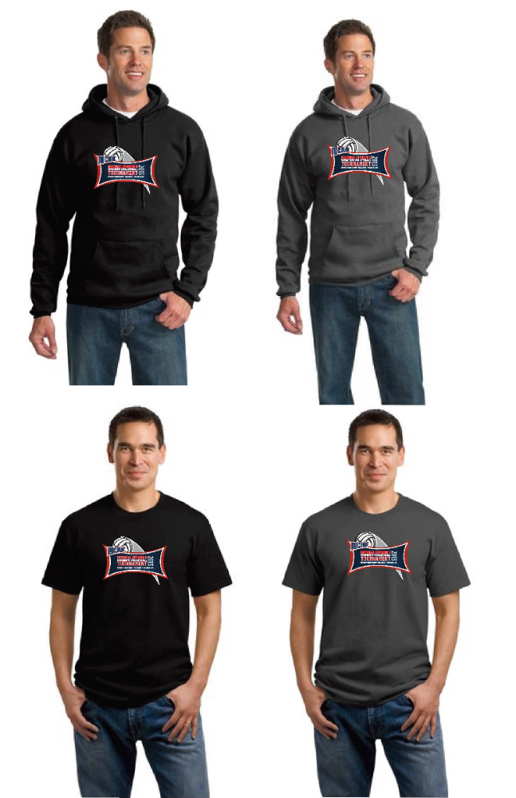

REGISTRATION CHECKLIST

______ Team registration emailed

______ Team Roster emailed

______ Merchandise Order Form emailed

______ 5x7 Team picture emailed

______ Banquet Reservation Form emailed

______ Media Outlet Form emailed

Email all information to: rudy_yovich@owens.edu
(Please put in the subject line- “NJCCA DIVISION II VOLLEYBALL NATIONAL CHAMPIONSHIPS”)

**ALL FORMS ARE DUE 12 NOON EASTERN STANDARD TIME ON TUESDAY, NOVEMBER 12, 2013.

Team Registration Form

College____________________________________________________________

Address____________________________________________________________

City_____________________ State____________ Zip __________

Phone________________________ Fax__________________________________

College President____________________________________________________

Athletic Director_____________________________________________________

Department Secretary_________________________________________________

Head Coach_________________________________________________________

Head Coach’s cell phone number________________________________________

Email______________________________________________________________

Assistant Coaches____________________________________________________

Athletic Trainer______________________________________________________

Mascot_____________________________Colors__________________________

Team Record____________________ NJCAA Region______________________

NJCAA Volleyball District____________________________________________

Please return completed form to rudy_yovich@owens.edu no later than 12 Noon Eastern Standard Time on November 12, 2013

Team Roster Example

College: Owens Community College

No. Name Ht. Pos. Yr. Hometown/Last School
1 Molly Hilfinger 5-10 S So. Whitehouse, OH/Anthony Wayne

2 Lisa Urbanski 5-4 DS Fr. Toledo, OH/Notre Dame Academy

3 Alyssa Meis 5-10 OH So. Curtice, OH/Genoa

4 Dakia Sellers 5-6 MB Fr. Mansfield, OH/Madison

5 Brandi Schimming 5-3 DS So. Martin, OH/Genoa

6 Bailey Windham 5-8 S Fr. Monroe, MI/Monroe Central Catholic

8 Dominque Yates 5-10 OH Fr. Toledo, OH/Bowsher

9 Tiffani Hobbs 5-10 OH Fr. Toledo, OH/Central Catholic

10 Kenzie Kleinhenz 6-2 OH Fr. St. Henry, OH/St. Henry

13 Kennedy Geyman 5-6 DS Fr. Monroe, MI/Jefferson

14 Jazmine Thomas 6-1 MB Fr. Lima, OH/Lima Sr.

Head Coach: Sonny Lewis

Assistant Coaches: Denny Caldwell, Amanda Gray

Athletic Trainer: Janeen Ramirez

Director of Athletics: Rudy Yovich

Tournament roster is to be submitted in the above formatting in a Microsoft Word document to allow a cut & paste option for the program designer. Rosters will not be accepted in any other format.

The individuals listed on this roster will be considered your official travel party and will be those that receive passes to the tournament. One per player, 6 total for coaches, managers, trainers, AD’s or other VIPs.

Team rosters should be emailed to rudy_yovich@owens.edu by 12:00 noon Eastern Standard Time on November 12, 2013.

Media Outlet List

College_______________________________________________________

PLEASE LIST THREE MEDIA OUTLETS YOU WISH TO RECEIVE DAILY PRESS RELEASES, STATS, AND RESULTS.

Tournament PR Representatives:
Nicholas Huenefeld, Website/Media Relations, 567-661-7972

Outlet ________________________________________________________

Contact_______________________________________________________

Fax Number___________________________________________________

Email________________________________________________________

Outlet ________________________________________________________

Contact_______________________________________________________

Fax Number___________________________________________________

Email________________________________________________________

Outlet ________________________________________________________

Contact_______________________________________________________

Fax Number___________________________________________________

Email________________________________________________________

Please limit your contacts to three. One can be your local school SID who can send information to other outlets.

Please return completed form to nicholas_huenefeld@owens.edu no later than November 12, 2013

Banquet Information

Date/Time: November 20^{th,} 7:00 p.m.

Location: Depot Ball Room at the Holiday Inn French Quarter

Dress: Business Professional

Menu: “Betty’s Salad” with choice of Ranch or Betty’s Dressing, Herb Chicken, Broccoli, Fettuccine with Alfredo Sauce, Garlic Rolls and Butter, Coffee, Tea, Iced Tea or Milk and Irish Cream Cheesecake.

Cost: $25 per person: Players, Coaches, and School Administration ONLY.

ADVANCE BANQUET RESERVATIONS

College: ______________________________________________________

Coach/Contact Signature: ________________________________________

Number of players/coaches/administrators attending at $25 per person: ____

Total amount of check made payable to Owens Community College $______

Please fill out this form and e-mail to by 12 Noon, on November 12th.

Please note that this is a catered event and the number of dinner reservations made by November 12th must equal the check amount. We will not be able to increase or cancel any of your reservations prior to the event.

